Assignment 2 – Scheme

David Langley

15340201

Q1

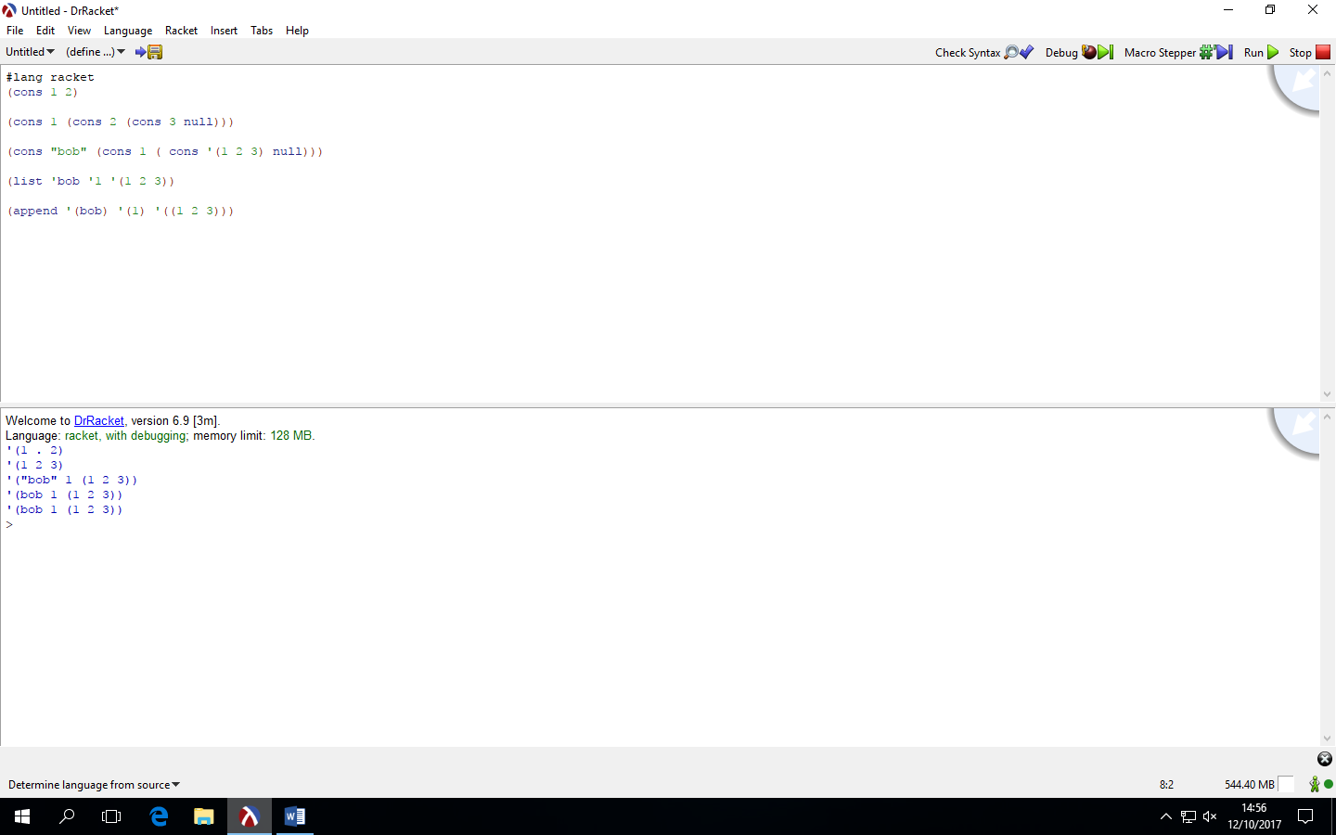

Comments on result:

For the cons part, to be able to have multiple numbers using cons properly you need to make sure you ‘loop’ the cons over and over to keep it using the right function that you want it to do. Using cons you need to use double quotes to be allowed to print string whereas the list and append functions don’t need that.

For the list function, it is a better cons function allowing for easier access to the values.

Then the append function is again another better version of the list function allowing for more values to be listed in the function without error.

Question 2

(A)

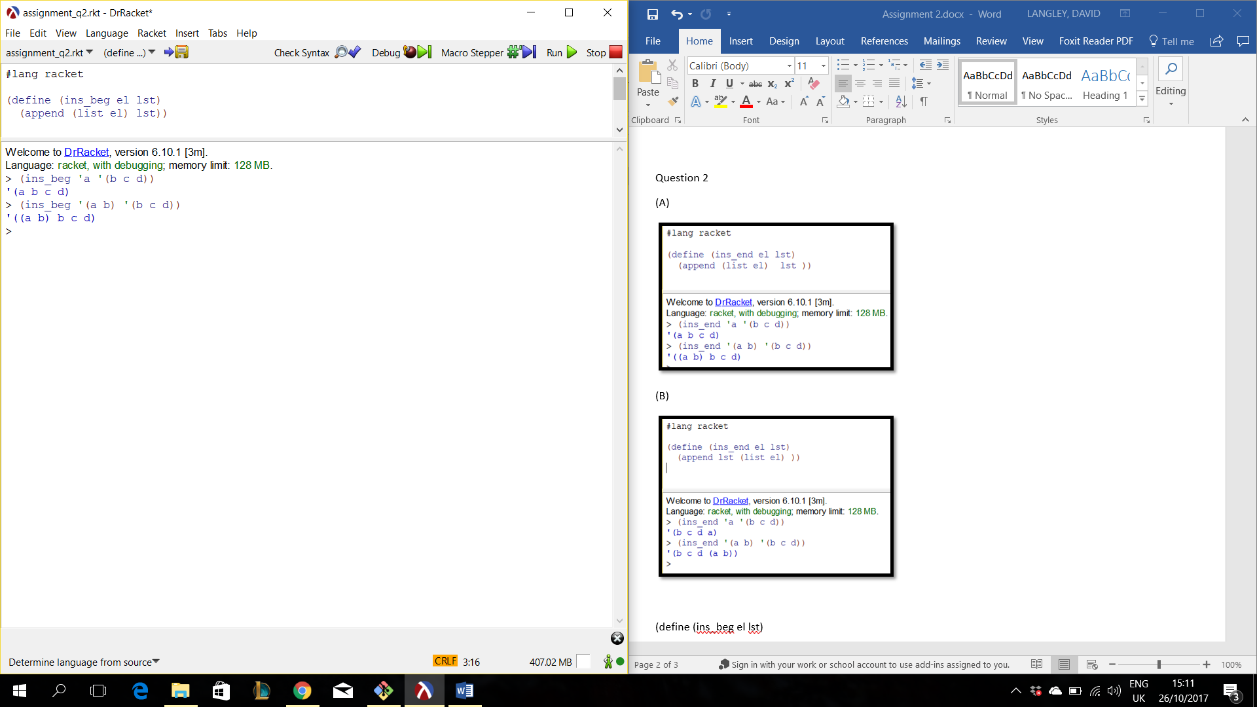

(define (ins_beg el lst)

(append (list el) lst))

(B)

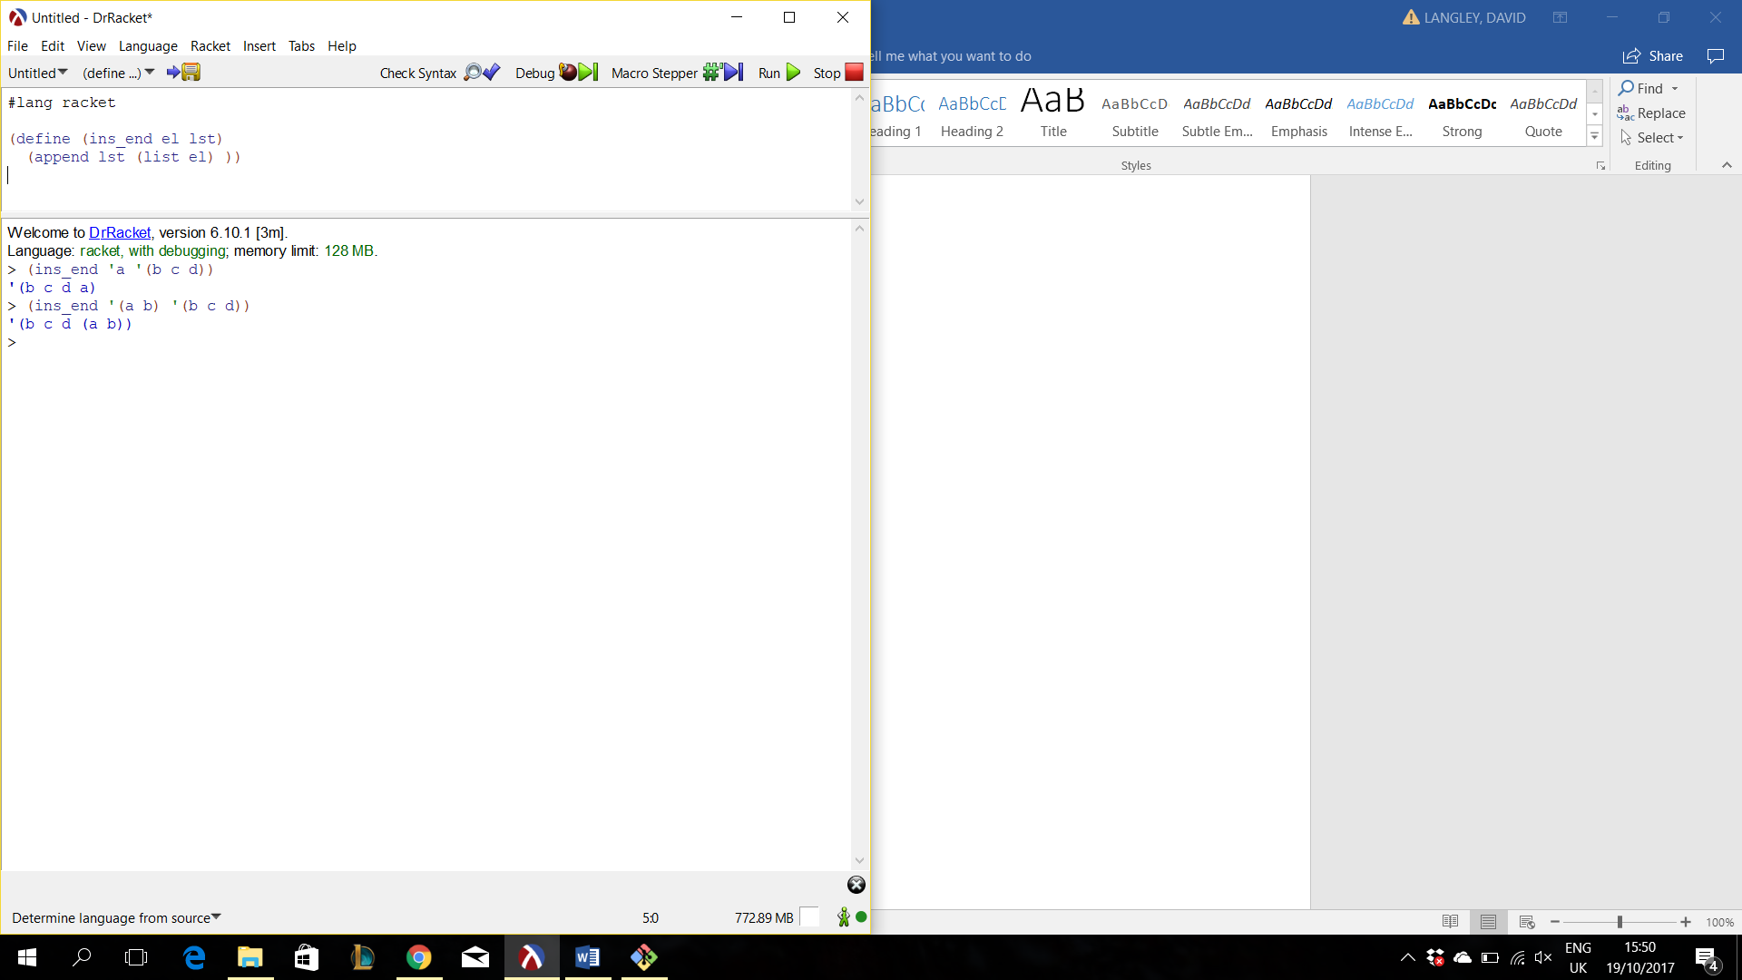

(define (ins_end el lst)

(append lst (list el)))

(C)

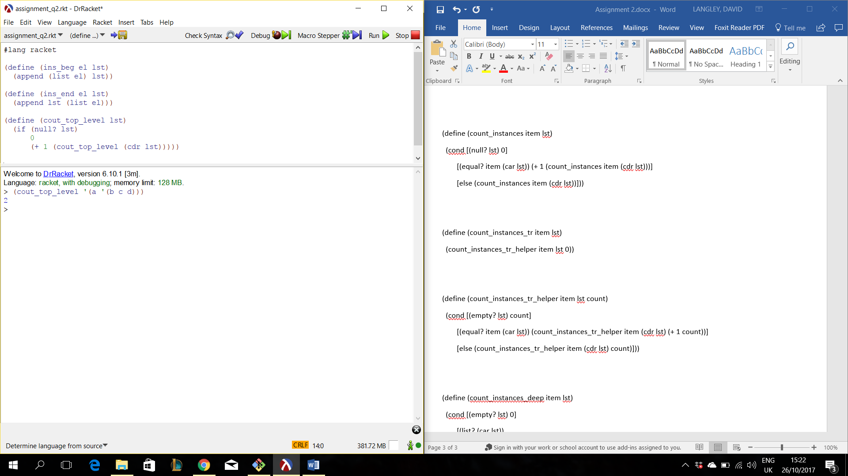

(define (cout_top_level lst)

(if (null? lst)

0

(+ 1 (cout_top_level (cdr lst)))))

(D)

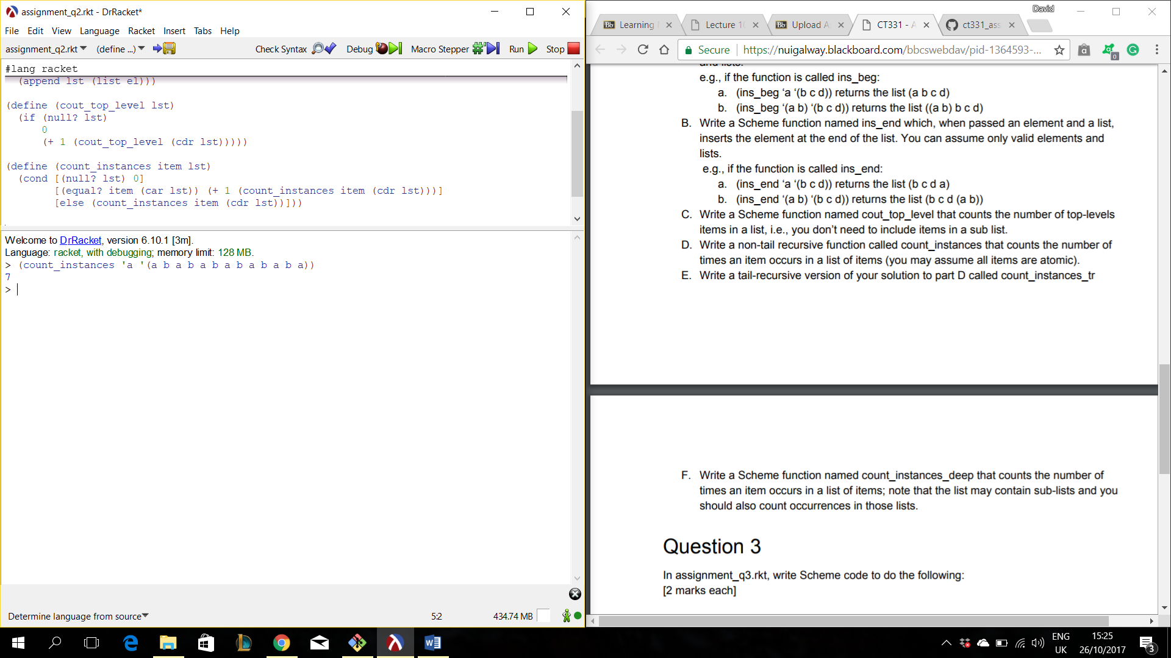

(define (count_instances item lst)

(cond [(null? lst) 0]

[(equal? item (car lst)) (+ 1 (count_instances item (cdr lst)))]

[else (count_instances item (cdr lst))]))

(E)

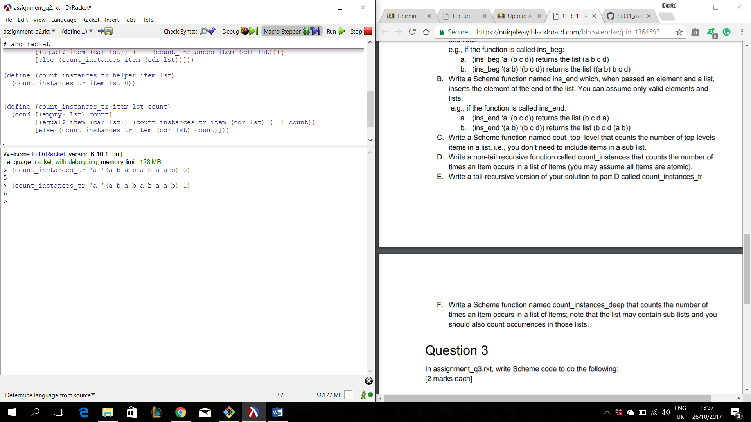

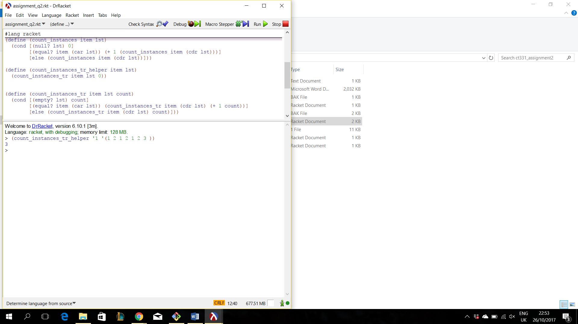

(define (count_instances_tr_helper item lst)

(count_instances_tr item lst 0))

(define (count_instances_tr item lst count)

(cond [(empty? lst) count]

[(equal? item (car lst)) (count_instances_tr item (cdr lst) (+ 1 count))]

[else (count_instances_tr item (cdr lst) count)]))

(F)

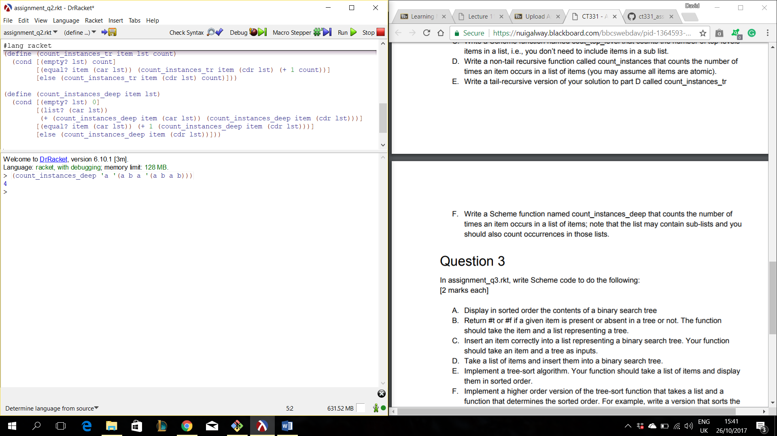(define (count_instances_deep item lst)

(cond [(empty? lst) 0]

[(list? (car lst))

(+ (count_instances_deep item (car lst)) (count_instances_deep item (cdr lst)))]

[(equal? item (car lst)) (+ 1 (count_instances_deep item (cdr lst)))]

[else (count_instances_deep item (cdr lst))]))

Question 3

(A)

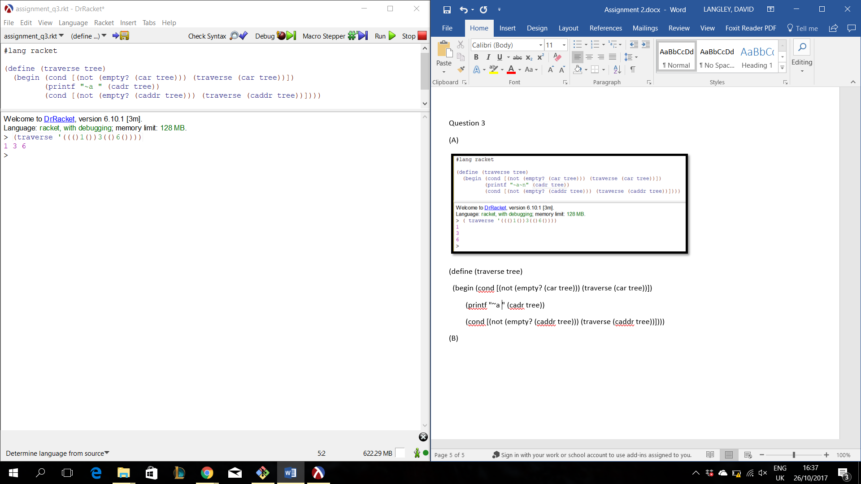

(define (traverse tree)

(begin (cond [(not (empty? (car tree))) (traverse (car tree))])

(printf "~a " (cadr tree))

(cond [(not (empty? (caddr tree))) (traverse (caddr tree))])))

(B)

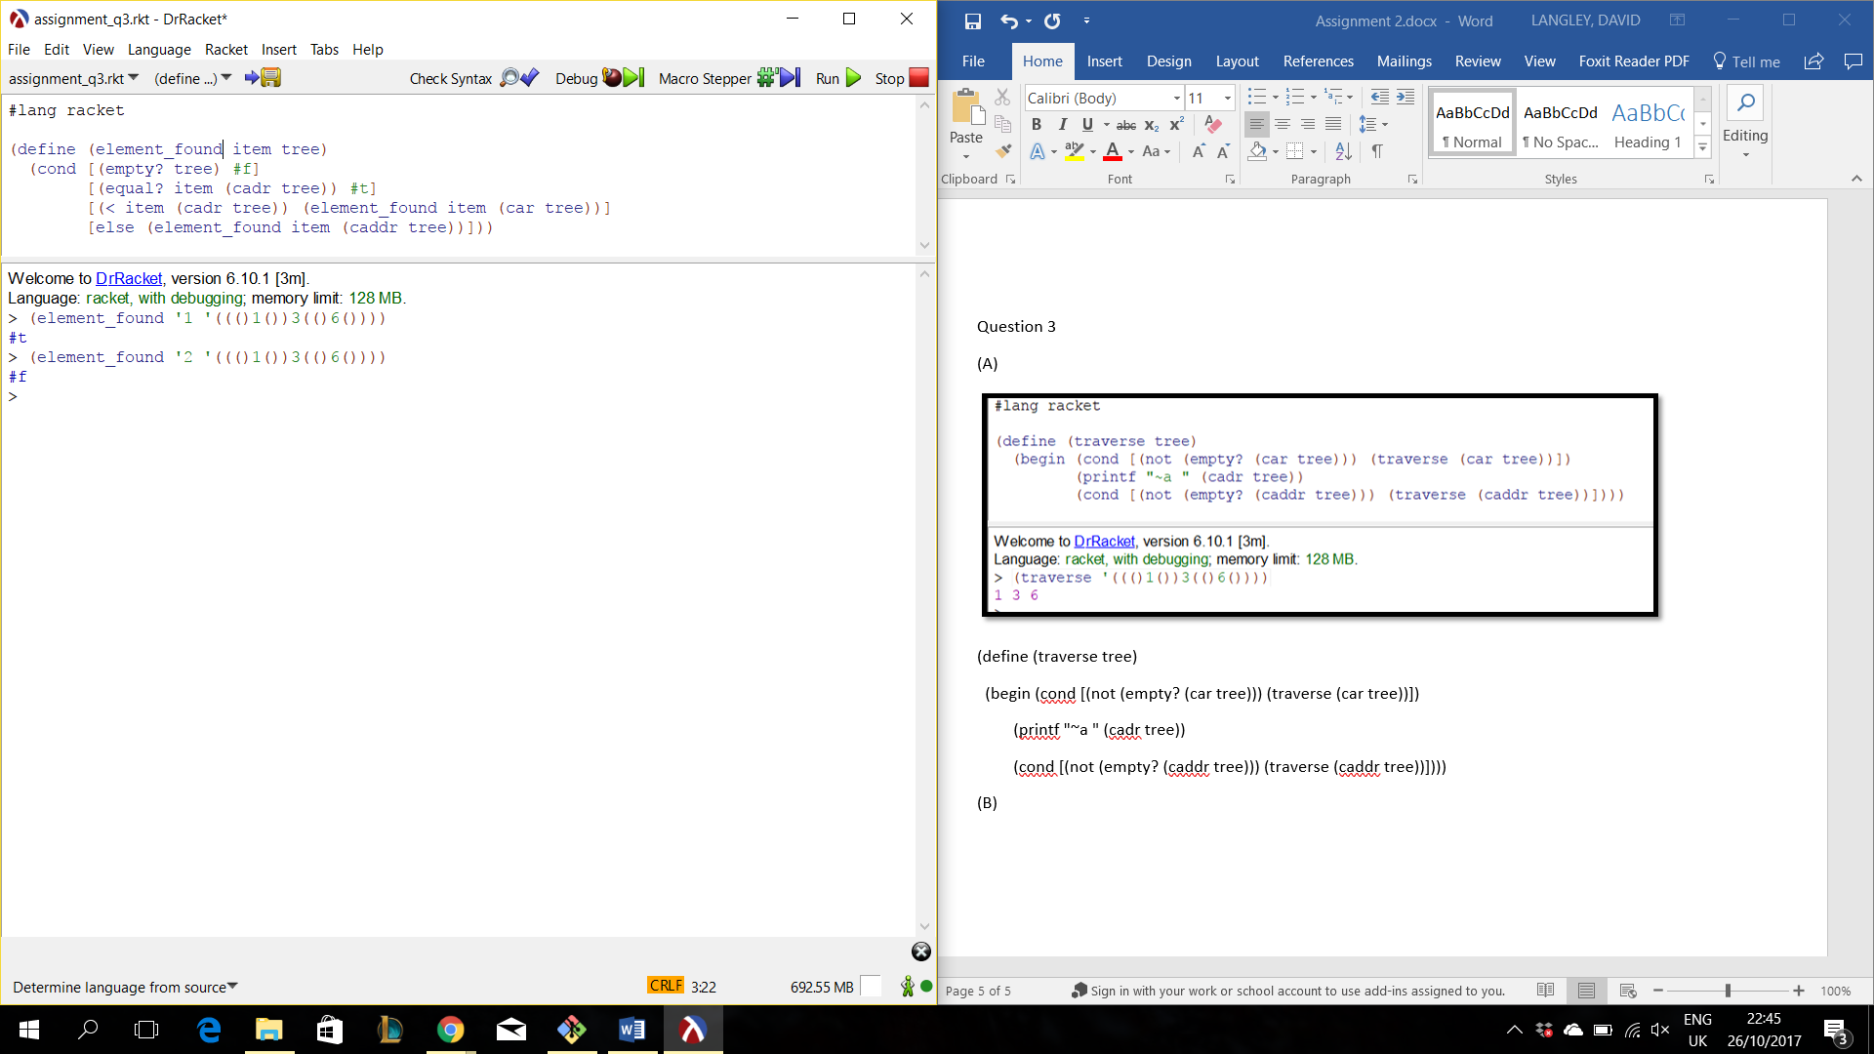

(define (element_found item tree)

(cond [(empty? tree) #f]

[(equal? item (cadr tree)) #t]

[(< item (cadr tree)) (element_found item (car tree))]

[else (element_found item (caddr tree))]))

(C)

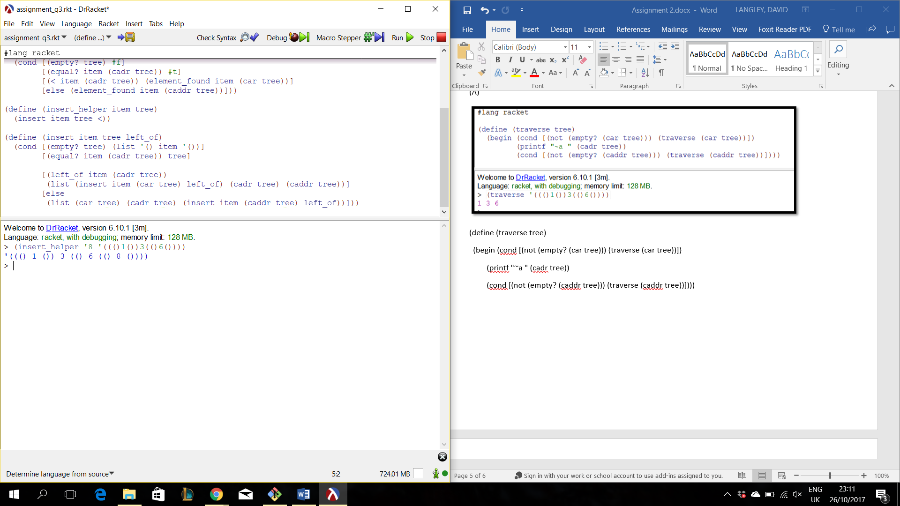

(define (insert_helper item tree)

(insert item tree <))

(define (insert item tree left_of)

(cond [(empty? tree) (list '() item '())]

[(equal? item (cadr tree)) tree]

[(left_of item (cadr tree))

(list (insert item (car tree) left_of) (cadr tree) (caddr tree))]

[else (list (car tree) (cadr tree) (insert item (caddr tree) left_of))]))

(D)

(E)

(F)

Unit Testing

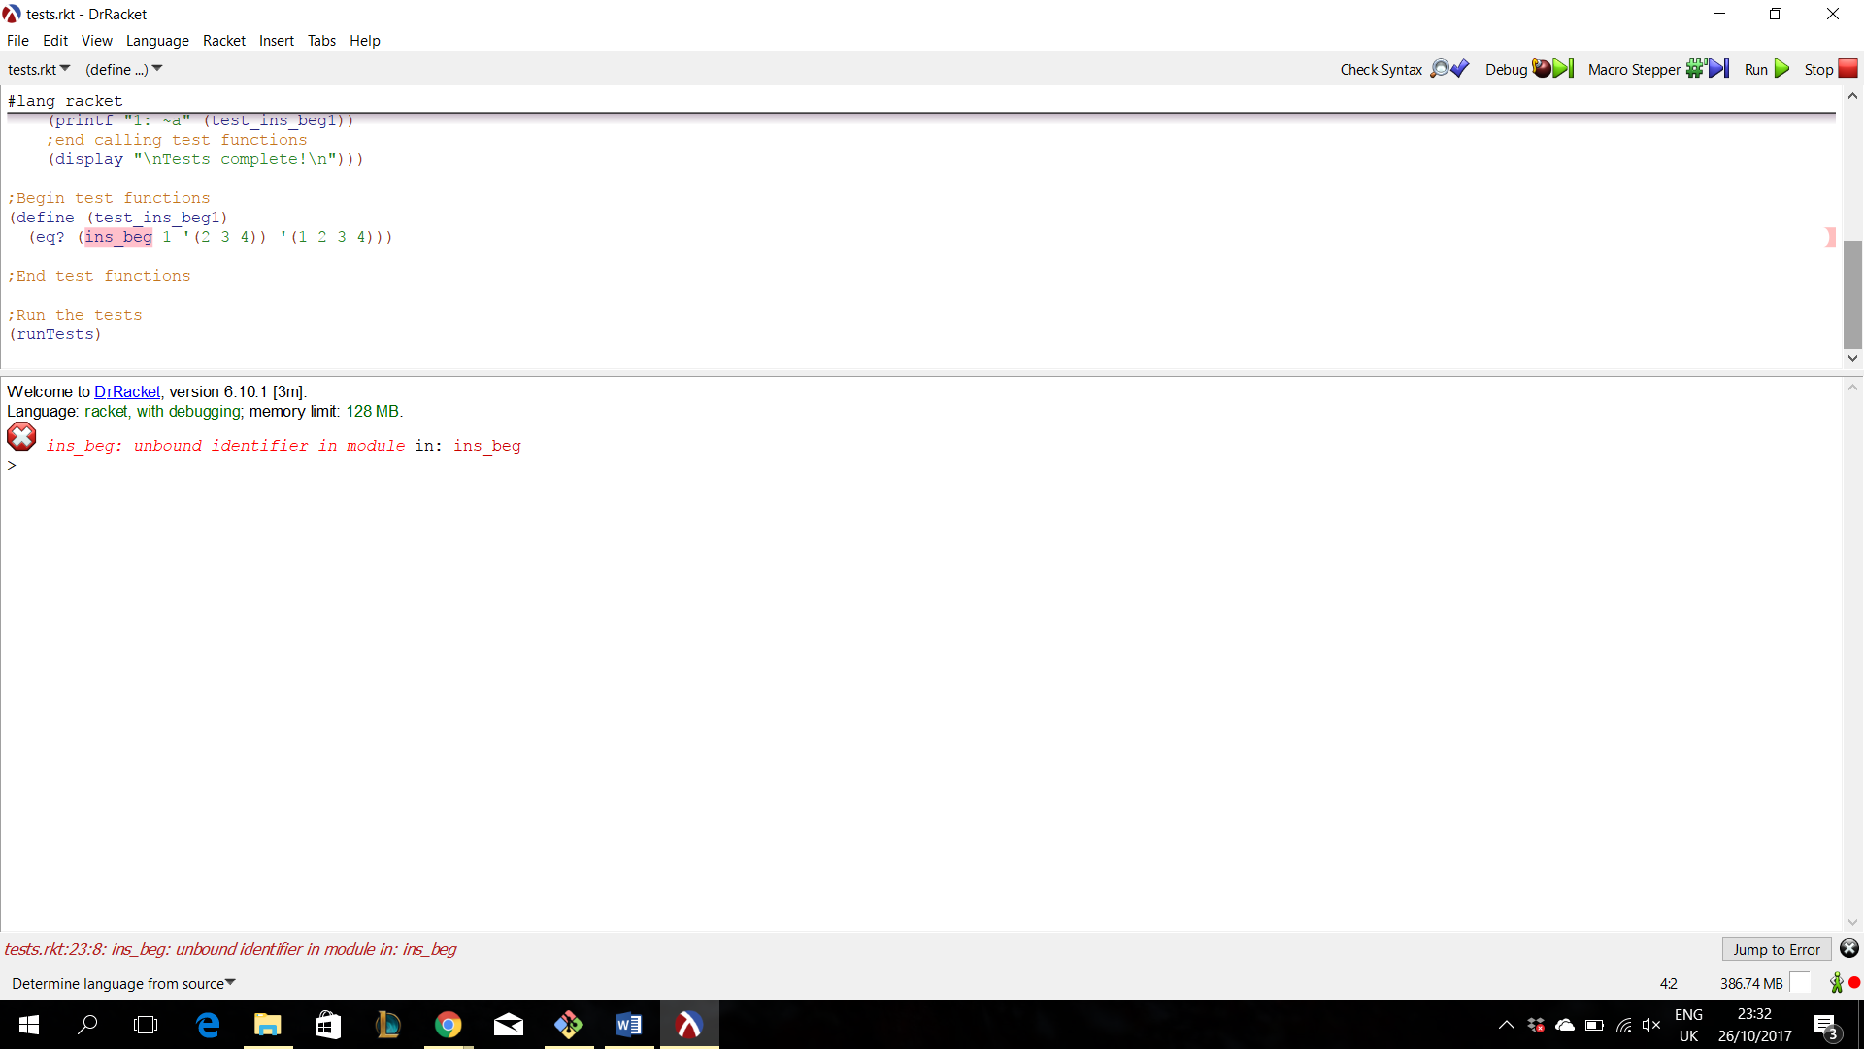

I don’t suppose there’s a problem there?

For the extra credit am I meant to fix this or something I can’t quite work it out.